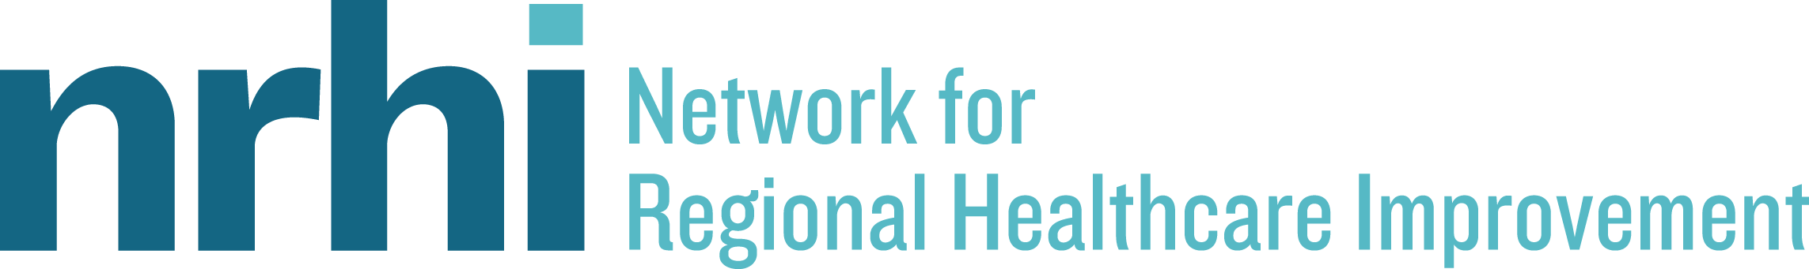

National Project to Reduce Healthcare Costs Revs into Second Phase

(PORTLAND, ME) July 9, 2015 – Increasingly the number of insured Americans continues to rise and Medicare enrollment climbs as more baby boomers enter retirement. The burning issue that needs immediate attention is controlling healthcare spending and never before has the momentum been greater toward payment reform from all interested stakeholders. Public and private payers, purchasers, consumers and healthcare providers of every size are recognizing that the status quo is no longer sustainable and change is inevitable.

The Network for Regional Healthcare Improvement (NRHI) today kicked off the second phase of a project designed to leverage healthcare cost data to reduce healthcare costs and improve care nationally. The grant-funded renewal project, Evolving the Regional Total Cost of Care Project and demonstrating preparedness for National Scalability (TCoC Phase II), is supported by the Robert Wood Johnson Foundation. The goal of the 18 month project is to evolve Total Cost of Care Reporting and show preparedness for national scalability, including adding new regions, expanding toward Public Payer inclusion, and supporting existing and new stakeholders as leaders in the effort to reduce cost and improve quality.

The phase I work completed by the five original pilot sites will provide a foundation for two new organizations during this renewal phase – HealthInsight Utah and the Maryland Health Care Commission. Both organizations not only met the minimum project requirements, they are also well positioned to be successful in their communities, and can provide new testing and learning opportunities to advance the work toward national scalability.

HealthInsight Utah is a Regional Health Improvement Collaborative and an NRHI member; they will partner with the Utah Department of Health (UDOH), Office of Health Care Statistics (OHCS), who manages the Utah All Payers Claims Database. The Maryland Health Care Commission, an independent agency in Maryland government with broad cost and quality reporting responsibility, manages Maryland’s APCD and has significant stakeholder engagement experience; they will partner with The Hilltop Institute at the University of Maryland Baltimore County for additional data and policy expertise.

The five original partnering organizations are: Center for Improving Value in Health Care (CIVHC); Maine Health Management Coalition (MHMC); Midwest Health Initiative (MHI); Minnesota Community Measurement (MNCM); and Oregon Health Care Quality Corporation (Q Corp). During Phase II, they will continue to evolve and fine-tune cost reporting data as well as expand the use of the data. The original sites will work more closely with physicians to provide tools and reduce barriers toward implementing cost measurement and containment in their local practices. The TCoC Phase II teams, led by NRHI, will also develop strategies and actionable steps to educate and engage employers interested in reducing overall cost of care.

The TCoC Phase II project allows the original sites to further develop their cost of care measures, use longitudinal data to evaluate trends, examine the impact of risk adjusters, and continue working toward standardization. Introducing new regions to the work allows for testing of new models for maximum leverage and adaptability in the rapidly changing healthcare transformation environment. The team will also collaboratively develop guidelines for All Payer Claims Databases (APCDs) interested in reporting total cost of care, as more detailed commercial and non-commercial data sets become available.

Earlier this year, NRHI held a national summit to report the findings from the first phase of this project. It was a well-attended gathering of healthcare leaders at the regional, federal and state levels. To view the keynote address, click here https://vimeo.com/132989042.

For more information about NRHI’s Total Cost of Care project, click here: http://www.nrhi.org/work/multi-region-innovation-pilots/tcoc/

About NRHI:
The Network for Regional Healthcare Improvement is a national organization representing regional multi-stakeholder groups working towards achieving the Triple Aim of better health, better care, and reduced costs through continuous improvement. NRHI and all of its members are non-profit organizations, separate from state government, working directly with physicians, hospitals, health plans, and patients using data to improve healthcare. For more information, visit us on the web at www.nrhi.org.

About RWJF:
For more than 40 years the Robert Wood Johnson Foundation has worked to improve the health and health care of all Americans. We are striving to build a national Culture of Health that will enable all to live longer, healthier lives now and for generations to come. For more information, visit www.rwjf.org. Follow the Foundation on Twitter at www.rwjf.org/twitter or on Facebook at www.rwjf.org/facebook.

